AAT LAB 4

Name : Swarangi Kothawade
Div/Roll No. : A-34

FRACTIONAL KNAPSACK
#include <iostream>
#include <algorithm>
using namespace std;

struct Item {
int value, weight;
};

bool compare(Item a, Item b) {
return (double)a.value / a.weight > (double)b.value / b.weight;
}

int main() {
int n;
cout << "Enter number of items: ";
cin >> n;

Item arr[n];

cout << "Enter value and weight of each item:\n";
for (int i = 0; i < n; i++) {
cin >> arr[i].value >> arr[i].weight;
}

int W;
cout << "Enter capacity of knapsack: ";
cin >> W;

sort(arr, arr + n, compare);

double totalValue = 0.0;

for (int i = 0; i < n; i++) {
if (W >= arr[i].weight) {
totalValue += arr[i].value;
W -= arr[i].weight;
} else {
totalValue += arr[i].value * ((double)W / arr[i].weight);
break;
}
}

cout << "Maximum value = " << totalValue;

return 0;
}
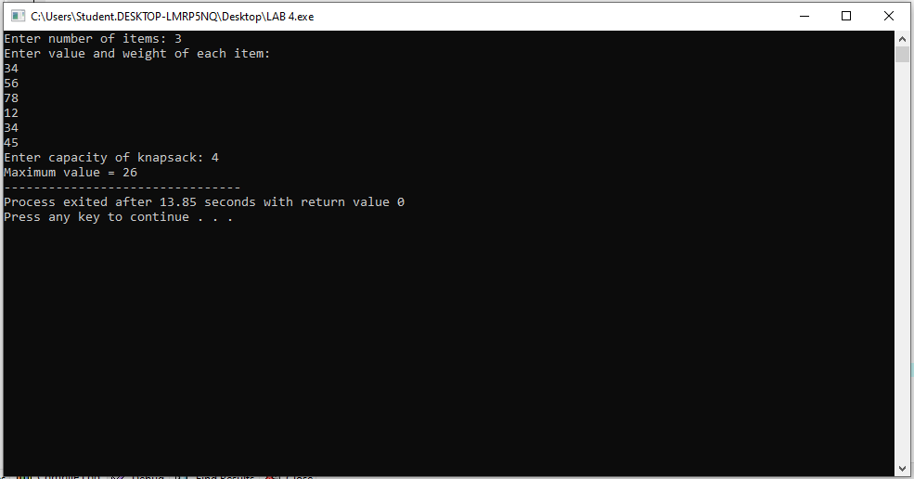

ACTIVITY SELECTION PROBLEM

#include <iostream>
#include <algorithm>
using namespace std;

struct Activity {
int start, finish;
};

bool compare(Activity a, Activity b) {
return a.finish < b.finish;
}

int main() {
int n;
cout << "Enter number of activities: ";
cin >> n;

Activity arr[n];

cout << "Enter start and finish time of each activity:\n";
for (int i = 0; i < n; i++) {
cin >> arr[i].start >> arr[i].finish;
}

sort(arr, arr + n, compare);

cout << "Selected activities:\n";

int lastFinish = arr[0].finish;
cout << arr[0].start << " " << arr[0].finish << endl;

for (int i = 1; i < n; i++) {
if (arr[i].start >= lastFinish) {
cout << arr[i].start << " " << arr[i].finish << endl;
lastFinish = arr[i].finish;
}
}

return 0;
}}
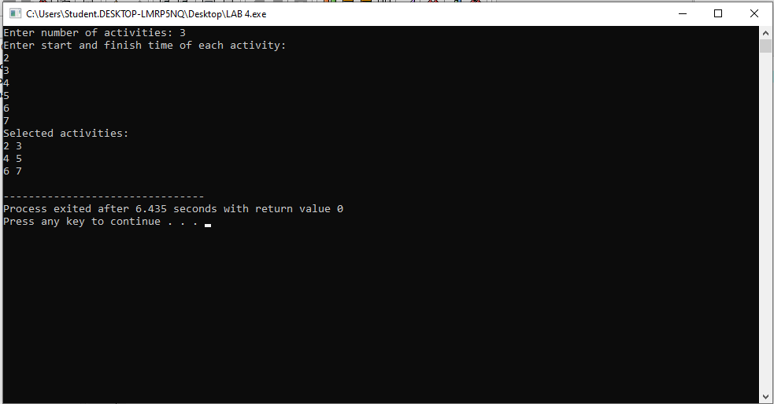

JOB SEQUENCING WITH DEADLINE

#include <iostream>
#include <algorithm>
using namespace std;

struct Job {
int id, deadline, profit;
};

bool compare(Job a, Job b) {
return a.profit > b.profit;
}

int main() {
int n;
cout << "Enter number of jobs: ";
cin >> n;

Job arr[n];

cout << "Enter job id, deadline and profit:\n";
for (int i = 0; i < n; i++) {
cin >> arr[i].id >> arr[i].deadline >> arr[i].profit;
}

sort(arr, arr + n, compare);

int maxDeadline = 0;
for (int i = 0; i < n; i++) {
if (arr[i].deadline > maxDeadline)
maxDeadline = arr[i].deadline;
}

int slot[maxDeadline + 1] = {0};
int totalProfit = 0;

for (int i = 0; i < n; i++) {
for (int j = arr[i].deadline; j > 0; j--) {
if (slot[j] == 0) {
slot[j] = arr[i].id;
totalProfit += arr[i].profit;
break;
}
}
}

cout << "Selected Jobs: ";
for (int i = 1; i <= maxDeadline; i++) {
if (slot[i] != 0)
cout << slot[i] << " ";
}

cout << "\nTotal Profit = " << totalProfit;

return 0;
}
